**CHAPTER TWO**

**LITERATURE REVIEW**

**2.1 Introduction**

The purpose of this chapter is to show how the problem under consideration relates to prior research, current practice, or other fields of knowledge by citing relevant works by other researchers who have dealt with a similar issue. Furthermore, this chapter will include a synthesis of current research on the issue, highlighting areas of agreement, disagreement, and gaps in the literature, to establish the significance of the project topic in the field and to recommend opportunities for future study.

**2.2 Literature Review**

Juliana et al. (2020). Evecurate – A Smart Event Management App Using Flutter and Firebase. This project focuses on transforming traditional event management processes in colleges and universities by introducing a mobile application called "Evecurate." The app streamlines various aspects of event planning, budgeting, communication, and audience engagement. It utilizes QR technology for efficient check-ins and audience interaction, such as event reviews and polls. Overall, "Evecurate" aims to replace cumbersome traditional event management methods with a more efficient and modernized system.

The "Evecurate" mobile application went thorough requirements analysis, gathering input from event organizers and stakeholders. Juliana et al. then selected the appropriate technologies, opting for a Hybrid Mobile Application using the Flutter SDK, while integrating QR code and instant messaging technology. The design and prototyping phase focused on creating an intuitive user interface and testing the application's core functionalities. This methodology ensures the efficient development of "Evecurate," transforming conventional event management into a smart and user-friendly system.

The researchers recommended integrating features like live chatting, video conferencing, live map navigation, and face recognition into the "Evecurate" mobile application to enhance its functionality. These enhancements will not only set "Evecurate" apart from competitors but also foster real-time student interaction, facilitate remote event participation, provide GPS-based navigation to event venues, and offer a secure check-in process through facial recognition technology, thereby improving overall user engagement, accessibility, and security.

The research gap in the study of the "Evecurate" mobile application lies in the absence of a thorough investigation into user adoption and acceptance factors, Addressing these areas would enhance the understanding of challenges and opportunities in modernizing event management through such applications, ultimately contributing to a more robust and user-centric solution

Shah et al. (2023). Event Management Systems (EMS). This study aims to develop a web-based Event Management System (EMS) to streamline event planning and organization on a single digital platform, eliminating the need for users to switch between different consoles and enhancing convenience. The research encompasses four key strategies, including technical research, EMS development, mixed-method data collection, and data analysis. The study also outlines the system architecture, project plan, and implementation process of the EMS. Furthermore, the system's functionality was evaluated through testing conducted by two users, both from the client and admin perspectives, to assess its effectiveness and usability.

The event management system was constructed using Rapid Application Development (RAD) which involves careful consideration of critical development factors through comparative investigations. The selection of technologies is based on their compatibility and ability to maintain overall system performance. Specifically, the system will be developed in two programming languages, React JS for the front end and Express.js for the back end, with Microsoft's Visual Studio Code 2019 as the primary integrated development environment (IDE). The backend construction will rely on Express.js and MongoDB to efficiently handle queries, while Node.js will serve as the chosen web server. Furthermore, the user interface design will be enhanced using the CSS framework Tailwind, ensuring optimal compatibility with popular web browsers.

The researchers recommended that improvements should be made to the EMS web application based on user feedback and emerging technological advancements. Despite limitations like time constraints and technical expertise, collaboration with a diverse team and seeking external support if needed can aid in enhancing system functionality. Regular user testing and feedback collection should continue to ensure the application aligns with user expectations and remains user-friendly.

The study does not delve into the specific challenges and barriers that users might face during the implementation and utilization of the EMS, which is critical for understanding the user experience.

Pansare et al. (2023). Smart College Event Management System Using MERN Stack. This study emphasizes the importance of events in college life and the increasing complexity of managing event details with conventional tools like spreadsheets and databases. To address these limitations, a new Smart Event Management System has been developed using web development technology. The primary goal of the project is to establish an efficient Event Management System for the college, with a particular focus on automating data management and report generation. This initiative is driven by the need to rectify the deficiencies and inefficiencies observed in traditional college event management systems.

The methodology for developing the Smart Event Management System (EMS) relies on a combination of web technologies and the MERN (MongoDB, Express.js, React.js, Node.js) stack. HTML is used for structuring content, CSS for styling, and JavaScript for dynamic web-behavior. The MERN stack facilitates a three-tier architecture, with React.js for the front end, Express.js and Node.js for server operations, and MongoDB for data storage. This approach ensures a robust and user-friendly web-based EMS.

Future research and development efforts should focus on expanding the system'’s capabilities and accessibility. Consider adding new features and functionalities to enhance user experience. Exploring the development of a mobile application for both iOS and Android platforms is essential, as it would improve accessibility and accommodate a broader user base. Additionally, implementing features like improved profile management and QR code-based guest registration would enhance the system'’s usability. This ongoing development will ensure the system remains user-friendly and aligned with evolving user needs.

The research gap identified in the study is that it does not delve into potential data security and privacy concerns associated with the storage and management of event-related information in the system

Sachin et al. (2019). A Study and Implementation of Event Management System Using Smartphone. This research highlights the development of an Android application for event management, with a focus on educational, medical, and social events. The application aims to address existing system problems and provide an accessible and user-friendly solution. It will be developed using Android Studio and will utilize an SQL database for backend management. The system allows users to register for events and offers basic functionality for event planning, including date and time selection, venue choice, and equipment selection. The data is stored in a database, and users receive a booking receipt. The administrator can interact with clients based on their requirements. Overall, the paper introduces an Android app designed to simplify event planning for users, catering to various event types.

The methodology for developing the Android event management application follows the Model-View-Controller (MVC) architectural pattern, which separates the app into three core components: Model, View, and Controller. The Model stores data independently, the View presents it through a user-friendly interface, and the Controller manages user interactions. This Android app targets educational, medical, and social events, developed using Android Studio and an SQL database. The goal is to provide a straightforward event planning experience for Android users.

This project serves as a good introduction to event management systems, including online ones. It explains the proposed system and its features while providing an overview of the technologies used. To make it even better, the researchers suggest exploring new and innovative features in the future. These improvements can keep the project relevant and aligned with changing user needs and industry advancements.

One notable research gap in this study is the lack of exploration of platform-specific challenges and compatibility issues

Mohana & Anbumani (2022). Online Event Management System. This research aims to address the evolving needs of clients in an increasingly digital world by developing an Online Event Management System. With the pervasive growth of technology, the project seeks to transition event planning and management into the online realm to better engage clients who are frequently on the move. The primary objectives include analyzing the current management practices employed by event planners and identifying the essential system requirements necessary for the design and implementation of an effective Online Event Management System.

The methodology involves using several technologies, including GPS, Android, XAMPP, PHP, and MySQL. GPS for location-based services, Android as the development platform, XAMPP as the local environment, PHP for server-side scripting, and MySQL for data management. These technologies are combined to create the event management application on Android.

This online event management system offers unique features and can be applied to different settings and event scales, including smaller local events often overlooked by existing systems. To fully realize its potential, it's advisable to explore diverse implementation possibilities and adapt the system to various event scenarios, ensuring its relevance and effectiveness in today's digital age.

The research gap is that the Online Event Management System (OEMS) lacks a comprehensive exploration of its adaptability to different event types. While OEMS caters to various events, the paper doesn't detail how it customizes processes for specific event categories. Further research is needed to understand how OEMS can offer tailored solutions for diverse event needs.

**2.3 Summary of Related Literature Reviews**

|  |  |  |
| --- | --- | --- |
| **Author & Year** | **Title & Description** | **Merit and Demerits** |
| Juliana et al. (2020). | Evecurate – A Smart Event Management App Using Flutter and Firebase.  This project focuses on transforming traditional event management processes in colleges and universities by introducing a mobile application called "Evecurate." The app streamlines various aspects of event planning, budgeting, communication, and audience engagement. | "Evecurate" efficiently modernizes event management, enhancing user engagement.  Lack of in-depth investigation into user adoption limits a comprehensive understanding of challenges and opportunities. |
| Shah et al. (2023). | Event Management Systems (EMS).  This study aims to develop a web-based Event Management System (EMS) to streamline event planning and organization on a single digital platform, eliminating the need for users to switch between different consoles and enhancing convenience. | The system provided convenience on event planning and organization.  The system limited to only web-browsers. |
| Pansare et al. (2023). | Smart College Event Management System Using MERN Stack.  This study emphasizes the importance of events in college life and the increasing complexity of managing event details with conventional tools like spreadsheets and databases | The study leverages the MERN stack for a robust, user-friendly web-based solution.  The system is limited to only Android-based users. |
| Sachin et al. (2019). | A Study and Implementation of Event Management System Using Smartphone.  This research highlights the development of an Android application for event management, with a focus on educational, medical, and social events | The system simplifies event planning for users.  The system lack scalability, high influx of user makes the site slow. |
| Mohana & Anbumani (2022). | Online Event Management System.  This research aims to address the evolving needs of clients in an increasingly digital world by developing an Online Event Management System. | The system makes use of GPS to enhance event planning and management.  The cost of the service is expensive. |

**CHAPTER THREE**

**Methodology and Design**

**3.1 Introduction**

A methodology is an approach to rigorous study or investigation, particularly to uncover new facts or information; hence, research methodology should be good enough to make the attainment of the established objectives attainable with certain components, such as methods of data collecting and design. This chapter includes the input/output specifications and system requirements for the development of mobile-based event planning and RSVP, as well as the system modeling (use case, activity, and class diagrams).

**3.2 Methods of Data Collection**

It is crucial to acquire data and facts about the current system before implementing any system since one has to understand what is happening. Two techniques were used to conduct this study.

1. Observation of the Work Environment
2. Documentation

**3.2.1 Observation of the Work Environment**

This strategy was used to collect information and data for this study by observing how the manual system functioned. Through close observation, the most obvious problems with the current system were found. The setting in which the observation is made can be changed in a variety of ways by using the observational method.

**3.2.2 Documentation**

Secondary data gathering includes documentation. Journals, manuals, previous work, publications, and other sources are used in this manner. This data-gathering strategy is chosen because it allows for comparison with previous research. This includes the internet, which is a tool for data collection. The internet was utilized to research complex or unclear problems.

**3.3 System Modeling**

A system model is a conceptual model that describes and represents a system. Any interaction between a group of components that work together to accomplish a single goal is referred to as a system. Visual models of the object-oriented software-intensive systems can be made using a set of graphic notation techniques that are part of the Unified Modeling Language, which is employed in this modern system design. Use case diagrams, class diagrams, and activity diagrams are among the UML diagrams used in this new design.

**3.3.1 Use Case Diagrams**

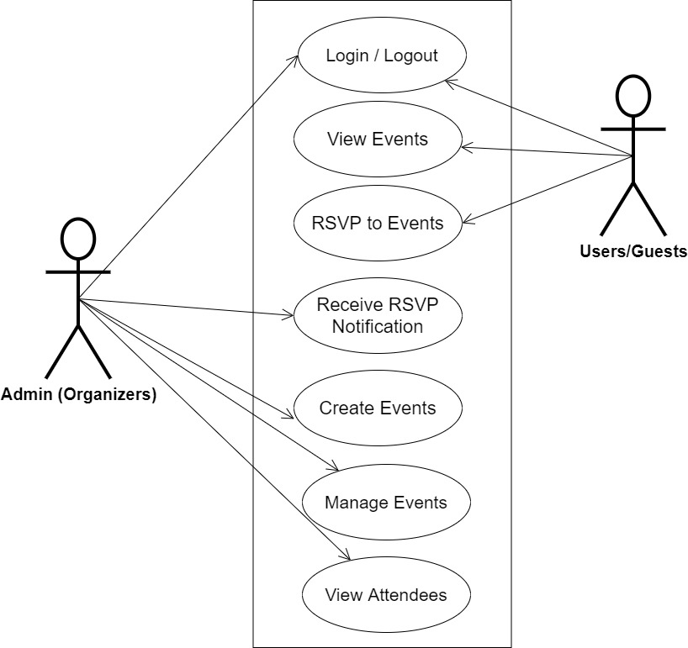Use cases are collections of interactions between systems and users. Use case diagrams are used to visually summarize a system's functionality in terms of its actors, its goals (represented as use cases), and any dependencies between those use cases.

**Fig 3.1 System Use Case Diagram**

**3.3.2 Class Diagrams**

The Unified Modeling Language (UML) class diagram is an implementation of an independent view of how the system interface might appear, with each class having its own set of properties and displaying how they interact with one another. Class diagrams use the Unified Modeling Language standards to visually depict the static structure and composition of a given system (UML).

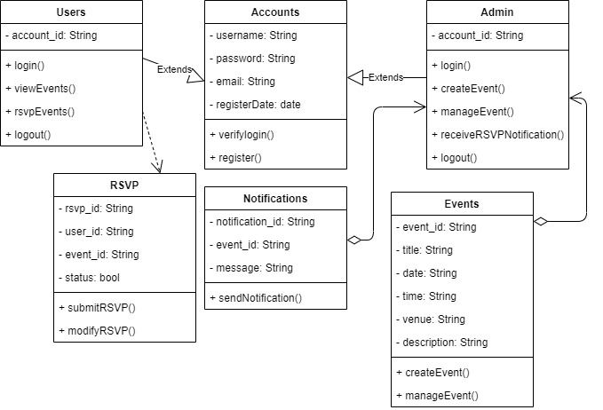

**Fig 3.2 System Class Diagram**

**3.3.3 Activity Diagrams**

An activity diagram, like a flowchart or a data flow diagram, visually illustrates a series of events or the flow of control in a system, but it acts more like an enhanced version of both.

**Login**

The process for gaining access to the system is depicted in the diagram below; the username and password must be accurate to gain access.

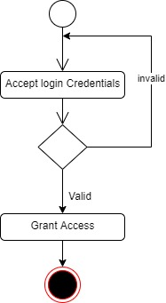

**Fig 3.3 Login Activity Diagram**

**Creating Event**

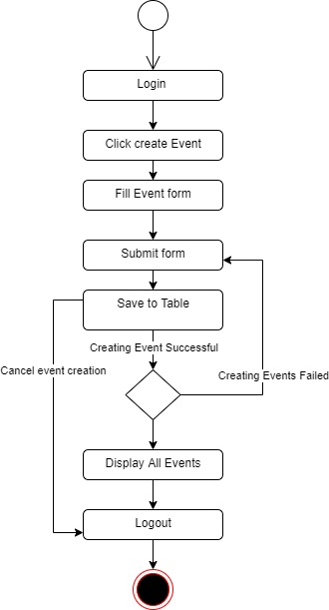The process for creating an event for users to respond to is depicted below, to create an event one has to be authenticated and must have proper authorization.

**Fig 3.4 Creating Event Activity Diagram**

**3.4 Database Design**

Input specification is the logical explanation of how data is stored in the computer's memory. SQL standards are vital for guaranteeing that structured data is uniform and independent of applications due to the flexibility experienced when using the system, as well as the simplicity of accessing and reading the data and ensuring applicability throughout the internet. The following are some of the input specifications used in this project effort.

1. Account Table: contains basic information about all system users.
2. Event Table: contains every system-saved event.

**Table 3.1 Account Input Specification Table**

|  |  |  |  |  |  |
| --- | --- | --- | --- | --- | --- |
| **Field Name** | **Data Type** | **Null** | **Key** | **Length** | **Description** |
| account_id | Varchar | No | PK | 32 | Unique string for identifying users |
| username | Varchar | No |  | 100 | Username |
| password | Varchar | No |  | 128 | User Password |
| email | Varchar | No |  | 100 | User Email Address |
| name | Varchar | No |  | 60 | User full name |
| is_organizer | Bool | No |  | 100 | Determine if a user is an organizer or not |

**Table 3.2 Event Input Specification Table**

|  |  |  |  |  |  |
| --- | --- | --- | --- | --- | --- |
| **Field Name** | **Data Type** | **Null** | **Key** | **Length** | **Description** |
| event_id | Varchar | No | PK | 32 | Unique string identifying events |
| title | Varchar | No |  | 60 | Title of the event |
| desc | Varchar | No |  | 100 | Event Description |
| venue | Varchar | No |  | 100 | Event Venue |
| time | Date | No |  | 20 | Event Time |
| date | Date | No |  | 20 | Event date |

**3.5 Output Design**

This declares and displays the outcome of the given input. This automated system's output is dependent on its input. The output specification is listed below.

**Table 3.3 Account** **output design table**

|  |  |  |  |  |  |
| --- | --- | --- | --- | --- | --- |
| **account_id** | **Username** | **Password** | **Email** | **Name** | **Is_organizer** |
| XXXX | XXXX | XXXX | XXXX | XXXX | XXXX |
| XXXX | XXXX | XXXX | XXXX | XXXX | XXXX |
| XXXX | XXXX | XXXX | XXXX | XXXX | XXXX |
| XXXX | XXXX | XXXX | XXXX | XXXX | XXXX |

**Table 3.4 Event** **output design table**

|  |  |  |  |  |  |
| --- | --- | --- | --- | --- | --- |
| **Event_id** | **Title** | **Desc** | **Venue** | **Time** | **Date** |
| XXXX | XXXX | XXXX | XXXX | XXXX | XXXX |
| XXXX | XXXX | XXXX | XXXX | XXXX | XXXX |
| XXXX | XXXX | XXXX | XXXX | XXXX | XXXX |
| XXXX | XXXX | XXXX | XXXX | XXXX | XXXX |

**3.6 Input & User Interface Design**

This is a graphic depiction of the system interface; it will be designed to be user-friendly, responsive, and visually beautiful. Furthermore, it will be fully secured, thus authentication will be required to see various levels of the information. To help with the designs, a mid-fidelity wireframing program called Draw.io is employed

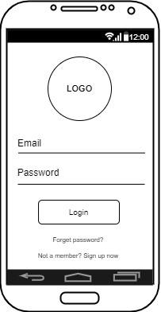

**Fig 3.5 User Login Screen**

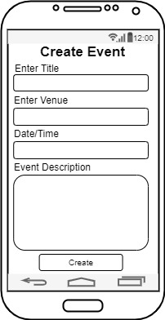

**Fig 3.6 Create Event Screen**

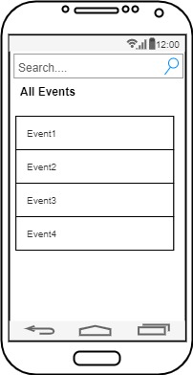

**Fig 3.7 All Events Screen**

**3.7 System Requirement**

Every piece of software that is created has preset system requirements that it must meet in order to run at its best. However, the system requirements are the bare minimum hardware and software needed for the system's intended operation.

**3.7.1 Hardware Requirement**

System Hardware requirements include:

a. Minimum of 8 GB of RAM (Random Access Memory) installed.

b. Minimum of intel core i3 processor.

c. Minimum of 250GB HDD (Hard Disk Drive).

**3.7.2 Software Requirement**

The software requirements include:

a. At least Windows 10 OS (Operating System).

b. Flutter Installation.

c. Vs. Code / Android studio installation.

d. Emulator installation.

**3.8 Choice of Programming Language**

The proposed design will be implemented using Flutter for its user interface (frontend) while the backend logic will be written in pure Dart, Firebase will be used for its database due to its simplicity, speed, and real-time feature, the combination of the above modern technology forms the technology for this research work.

**REFERENCES**

Navamani, M.C. (2023). EVENT MANAGEMENT SYSTEM. International Scientific Journal of

Engineering and Management.

Nirupama, B., & Mahitha N. (2023). College Event Management System. International Journal of

Scientific Research in Engineering and Management.

Pilato, D. (2022, May 23). What does RSVP mean on an invitation? *The Spruce*. https://www.thespruce.com/what-does-rsvp-mean-on-invitations-1196806

Pansare, A., Patil, A., Patil, N., Patil, Y., & Bhonde, Mrs. A. (2023). Smart College Event

Management System Using MERN Stack. International Journal for Research in Applied Science and Engineering Technology, 11(3), 2125–2129. https://doi.org/10.22214/ijraset.2023.49875

Sachin A., Altaf T., & Amol B. (2019). A Study and Implementation of Event Management System

Using Smartphone. The International Journal of Innovative Research in Engineering & Multidisciplinary Physical Sciences, 6(5), 2349-7300